

**OPERATING SYSTEM LAB**

**TAYYABA REHMAN 49690**

**LAB 9**

**TASK 1:**

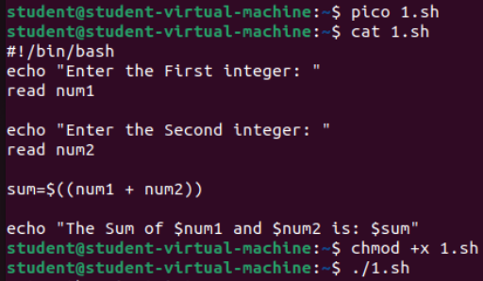

**Output:**

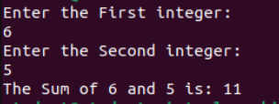

**TASK 2:**

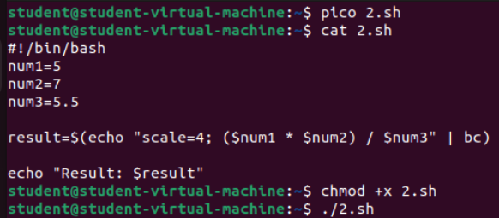

**Output:**

